Week 6 – Domain Model, System Sequence Diagram

Domain Model
Domain Model – structure model of basic domain objects and their relationships.
To develop a Domain Model, we follow the following steps:
- Identify conceptual classes
- Draw them as in a UML domain model
- Add associations (includes composition and aggregation) to show relationships
- Add attributes in classes
Domain Model diagram includes:
- Domain classes – type of object
- Attributes – properties that define a class
- Associations – link between two classes.
Example: A Person works for a Company
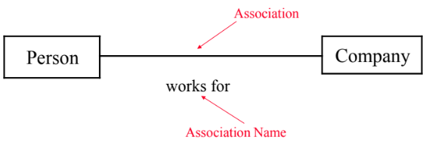
- Multiplicity – describes how many instances of a class can be associated with the instance(s) of another class.
Example: A Student can take up-to five Courses, but has to be enrolled in at least one Course. A Course can have up-to 300 Students, but should have at least 10 Students enrolled
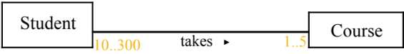
- Aggregation (Weak) – is a Has-a association between two classes
Example:
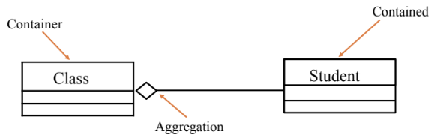
NOTE: if Class is deleted, Student still exists
- Composition (Strong) – is a Own-a association between two classes
Example:
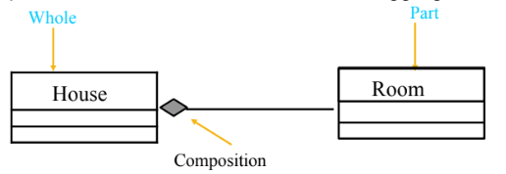
NOTE: if House is destroyed, Room is also destroyed
- Inheritance (Generalization) – shows an inheritance/parent-child relationship between two classes
Example:
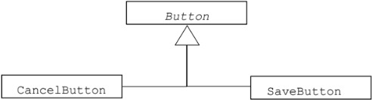

System Sequence Diagram (SSD)
System Sequence Diagram SSD – illustrates input and output events related to system under discussion
Notations in SSD are:
- Object – instances of classes. Represented as a rectangle
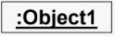
- Actor – shows a user or person who interacts with the system. Represented by stick figure

- Lifeline – identifies existence of object overtime. Represented by a vertical dotted line extending from the object.
- Message – indicates communication between objects. Represented as horizontal arrows
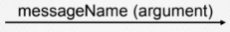

Fragments – boxes drawn around messages to show conditions & repetitions.
Types of Fragments include:
- alt – represents if-else condition. Box divided by a dashed line with each section having a guard condition in square brackets like [condition]
- loop – represents repetition. Box labeled “loop” with a condition like [for each item]
- opt – represents optional, single condition with no else. Executes only if the condition is true.
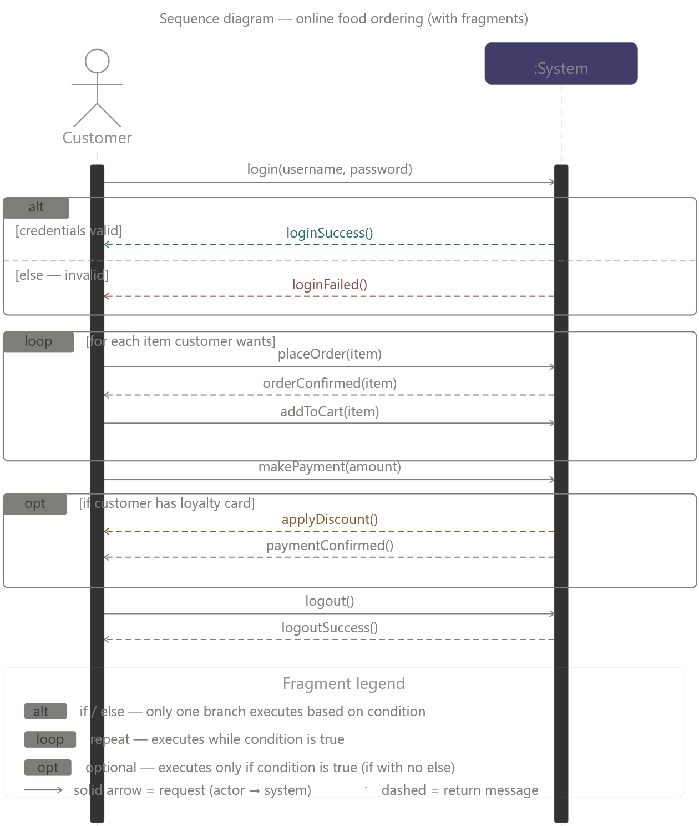

Week 7 – Reengineering Approaches, Code Refactoring

Reengineering Approaches
Five strategies for reengineering (i.e. modernizing a legacy system):
- Big Bang Approach – involves tearing down the entire system and rebuilding it over
Advantage: System moves to a new environment at all once, with no messy in-between states.
Disadvantage: requires huge resources in terms of time, effort, finance etc., no visibility to show to client until the end (very risky)
- Incremental Approach – reengineering system gradually module-by-module, releasing several new interim versions each time. Each version takes us closer to target system
Advantage: locating errors is easier; more visibility due to easier progress tracker (lower risk)
Disadvantage: version control makes it a time consuming process; does not allow architectural changes mid-process
- Partial Approach – divide the system into parts that require reengineering and that do not require reengineering, reengineer the identified parts, and lastly, integrate both parts back together.
Advantage: less time, less cost
Disadvantage: compatibility issues may arise while integrating both parts
- Iterative Approach – work on a few procedures at a time in short cycles, repeatedly, across different components. Four types of components coexist: old not yet reengineered, currently being reengineered, already reengineered, and brand new.
Advantage: systems keeps running throughout, users stay familiar with it
Disadvantage: tracking all four components simultaneously is complex; both old and new components need maintaining
- Evolutionary Approach – Group components by function across the entire system and reengineer each functional group as one unit — think "all the plumbing in the house" rather than room by room.
Advantage: the resulting system is more cohesive with each component having a cleaner, reduced scope
Disadvantage: hard to identify all similar functions across the system

Code Refactoring
Refactoring – systematic process of improving code without changing what it does.

Dirty Code – result of inexperience, tight deadlines, mismanagement and nasty shortcuts taken during development process
Clean Code – code that is easy to read, understand and maintain

Refactoring Techniques:
- Composing Methods: streamline methods, remove code duplication, and break giant methods into smaller ones.
Example: printMarksheet() becomes printDetails() + printGrades().
- Moving Features between Objects: move a method to the class it actually belongs to.
Example: overdraftCharge() was in Account but used AccountType's data — move it to AccountType.
- Organizing Data: helps with data handling by replacing primitive data types with rich class functionality.
Example: a plain string “5550199” is converted to a PhoneNumber class object
- Simplifying Conditional Expressions: extract messy if-else logic into name methods (decompose conditional statements).
Example: a conditional expression to check if its summer becomes isSummer(date)
- Simplifying Method Calls: replace flag-based methods with separate explicit methods.
Example: setValue(“height”, x) becomes setHeight(x) and setWidth(x)
- Dealing with Generalization: move shared fields/methods to parent class.
Example: both Salesman and Engineer had a name attribute – move it up to Employee parent class
Code Smells:
- Bloaters: code, methods and classes that are too big (have too many lines of code).
Examples: Long Method, Large Class, Primitive Obsession, Long Parameter List, Data Clumps
- Object -Orientation Abusers: incomplete or incorrect application of OOP principles
Examples: Alternative Classes with Different Interfaces, Refused Request, Switch Statements, Temporary Field
- Change Preventers: one change forces many other changes.
Examples: Divergent Change, Parallel Inheritance Hierarchies, Shotgun Surgery
- Dispensables: pointless stuff that should be deleted to make the code cleaner and understandable.
Examples: Comments, Duplicate Code, Data Class, Dead Code, Lazy Class, Speculative Generality
- Couplers: classes are too tangled with each other.
Examples: Feature Envy, Inappropriate Intimacy, Incomplete Library Class, Message Chains, Middle Man

Week 8 – Source Code Reengineering Reference Model (SCORE/RM)
Proposed by Colbrook, Smythe and Darlison.
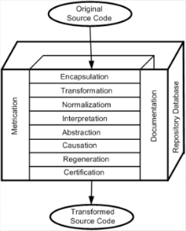

Types of SCORE elements:
- Function – the 8 layers where actual processing happens.
The top six layers constitute a process for reverse engineering, while the bottom three constitute a process for forward engineering..
Both processes include causation, because it represents the derivation of requirements from software system
- Documentation – describes specifications, constraints, and implementation details of both old and new versions of the software.
- Repository Database – central storage for the entire reengineering process containing information such as metrication, documentation, old source code, new source code etc.
- Metrication – measures software quality before and after each layer to quantify improvement

Types of Interfaces:
- Metrication/Function (N)-MF: carries metrics and their values
- Documentation/Function (N)-DF: carries documentation
- Function/Function (N)-FF: carries source code between layers
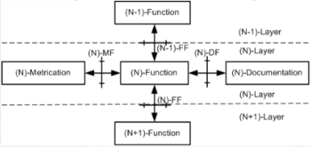
Function Layers:
- Encapsulation: a reference baseline is created from original source code to uniquely identify a version of a software and facilitate its reengineering.
Sub-functions include:
  - Configuration – record all changes made to the software
  - Analysis – evaluate what needs to be reengineered, build cost models
  - Parsing – translate source code into Intermediate Language (IL) — all further work operates on IL, not original code
  - Test Generation – design baseline acceptance tests from original code
- Transformation: (untangle the wiring) changing control flow to make code structured.
Sub-functions include:
- Rationalization of Control Flow – remove spaghetti code
- Isolation – identify all external interfaces and dependencies
- Procedural Granularity – size procedures using high cohesion and low coupling

- Normalization: (declutter the data) scrutinize and clean up data and data structures.
Sub-functions include:
- Data Reduction – eliminate duplicate data, align database with program requirements
- Data Representation – generate life histories of data (how it changed and what controls act on it)
- Interpretation: (figure out what it means) deriving the actual meaning of software.
Sub-functions include:
- Functionalization – eliminate global variables, introduce recursion and polymorphic functions
- Program Reading – annotate source code with logical comments to explain what each section does
- Abstraction: (find the objects) examine annotated code to identify underlying object hierarchies.
Sub-functions include:
- Object Identification – separate data operators and group them with data they manipulate
- Object Interpretation – map real-world domain meanings onto identified objects
- Causation: (the bridge between RE and FE) derives requirements. This is where reverse engineering ends and forward engineering begins.
Sub-functions include:
- Specification of Actions – define what software does for user
- Specification of Constraints – define limits within a software operates
- Modification of Specification – extend or reduce the specification to accurately reflect actual user requirements

- Regeneration: (rebuild) re-implement source code using derived requirements
Sub-functions include:
- Generation of Design – produce and document detailed design
- Generation of Code – generate new code, reusing original portions and standard libraries
- Test Generation – create unit & integration tests for new code
- Certification: (final quality check) confirm new software works correctly and is consistent with original
Sub-functions include:
- Validation and Verification – test new system for correctness
- Conformance – confirm new system does everything original did

Week 9 – Phase Reengineering Model
Proposed by Byrne and Gustafson.

Phases of PRM:
- Analysis & Planning – includes understanding scope of work, identifying required resources, identifying tasks, estimating required effort and preparing a schedule.
This phase addresses the following technical issues:
- What does the current system look like?
- Why does it need to be reengineered?
- What should the new system look like?
And, the following economical issue:
- Is reengineering cheaper than rebuilding or just maintaining?
- Renovation – operational system is modified into the target system here.
Two aspects of a system are considered in this phase:
- Representation of the System – source code, but may include design model and requirement specification of existing system
- Representation of the External Data – database used by system
- Target System Testing – Test the new system for faults introduced during renovation. Run the same test cases on both old and new systems — since requirements are identical, results must match.
- Re-documentation – Update all documentation to reflect the new system.
Two major tasks within this phase are:
- analyze new source code
- create new documentation.
Documents requiring revision are requirements, design docs, user manuals, online help, and a document describing what changed between old and new.
- Acceptance Testing and System Transition – Test against acceptance criteria set at the very beginning. Pass → system goes live, old system retired. Fail → fix the faults, sometimes even after deployment.

Week 10 – Code Reverse Engineering
According to Chikofsky and Cross II: Reverse Engineering is identifying components of an operational software, relationships among these components, and representing systems at a higher level of abstraction.

Why is it needed?
- Original programmers have left the organization
- Language of implementation has become obsolete
- Insufficient documentation of the system.
- The business relies on software, which many cannot understand.
- The company acquired the system as part of a larger acquisition and lacks access to all the source code.
- System requires adaptations and/or enhancements.
- Software does not operate as expected.

Levels of Reverse Engineering:
- High-Level Reverse Engineering – creating abstractions of source code in form of design, architecture, or documentation.
- Low-Level Reverse Engineering – creating source code from object code or assembly code.

Objectives of Reverse Engineering:
- Redocumentation of Artifacts – revising current descriptions of components at the same abstraction level
- Design Recovery – rebuilding design blueprint from code + expert knowledge

Objectives of Reverse Engineering (according to Chikofsky and Cross II):
- Generating alternative views.
- Recovering lost information.
- Synthesizing higher levels of abstractions.
- Detecting side effects.
- Facilitating reuse.
- Coping with complexity.

Steps to Reverse Engineering:
- Partition source code into units
- Describe meanings of those units and identify functional units
- Create input and output schematics of units identified before
- Describe connected units
- Describe system application
- Create an internal structure of system

Goals/Models/Tools Paradigm (Benedusi) – framework for organizing reverse engineering process
- Goals stage – identify why you’re doing it and what information you need
- Models stage – create representation models that define how to extract and represent information
- Tools stage – identify tools needed to extract information and generate required documents

Week 11 – Reverse Engineering Techniques: Lexical Analysis
Lexical Analysis is the process of breaking source code into smaller units called tokens.
It is the first phase of a compiler and is also known as scanner, lexer, or tokenizer.
Lexical Analysis can be implemented via Deterministic Finite Automata (DFA)

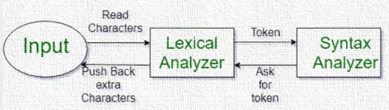
The Lexical Analyzer reads the source code character-by-character and groups them into meaningful units.
The output generated is then sent to the parser for syntax analysis.

Token is a sequence of characters treated as a single meaningful unit in a programming language grammar.
Examples of Token:
- Keywords like if, else, while, for, return
- Identifiers including variable name, function name etc.,
- Operators like +, -, ++, =
- Separators/Punctuation like ; (semi-colon), , (comma), (, )
Examples of non-tokens:
- Comments
- Macros
- Preprocessor directives
- Blank spaces
- Tabs
- New lines

Lexeme is the actual sequence of characters in the source code that matches a token pattern and are grouped together as a single unit.
Examples of Lexems:
Lexeme | Token Type
main | Identifier
( | Punctuation
) | Punctuation
{ | Punctuation
} | Punctuation

NOTE! Important Difference
- Token = Category/type
- Lexeme = Actual text from source code

Working of a Lexical Analyzer:
- Input Preprocessing
- The source code is cleaned before tokenization, where non-essential elements like comments, extra spaces, tabs, new lines etc., are removed.
- This makes input easier to process.
- Tokenization
- The source code is divided into tokens.
- Characters are matched against a set of predefined patterns or expressions that define different types of tokens
- Example:
  - Code:
a = 10;
  - Tokens:
a , = , 10 , ;
- Token Classification
- The Lexical Analyzer determines type/category of each token
- Example:
Token | Classification
if | Keyword
a | Identifier
+ | Operator
; | Separator

- Token Validation
- The Lexer checks whether the tokens follow language rules
- Checks may include checking whether variable names are valid identifiers, operators have correct syntax, numbers are correctly written
- Example:
int 1abc; is invalid as identifiers cannot start with digits
- Output Generation
- Final output is generated as a list/stream of tokens, which is then passed on to the parser

Lexical Analyzer can detect lexical errors via automation machines and grammar rules of the language used. It also reports row number and column number of the error
Examples of Lexical Errors include misspelled keywords, invalid symbols, invalid identifiers.
Example:
innt a;

Example 1 – find valid tokens:
- Source Code:
int main()
{
int a = 10, b = 20;
printf("sum is: %d", a+b);
return 0;
}
- Valid Tokens:
‘int’ ‘main’ ‘(‘ ‘)’
‘{‘
‘int’ ‘a’ ‘=’ ‘10’ ‘,’ ‘b’ ‘=’ ‘20’ ‘;’
‘printf’ ‘(’ ‘“sum is: %d”’ ‘,’ ‘a’ ‘+’ ‘b’ ‘)’ ‘;’
‘return’ ‘0’ ‘;’
‘}’
Total number of tokens = 27

Example of Lexeme and Token Representation:
 | Lexemes | Tokens |  | Lexemes | Tokens
1 | while | WHILE | 7 | a | IDENTFIER
2 | ( | LPAREN | 8 | = | ASSIGNMENT
3 | a | IDENTIFIER | 9 | a | IDENTIFIER
4 | >= | COMPARISON | 10 | - | ARTHIMATIC
5 | b | IDENTIFIER | 11 | 2 | INTEGER
6 | ) | RPAREN | 12 | ; | SEMICOLON

Advantages of Lexical Analysis:
- Simplifies Parsing
- Source code is converted into smaller manageable units
- Makes syntax analysis easier
- Helps compilers/interpreters understand program structure efficiently
- Early Error Detection
- Lexical errors are detected in early compilation stages
- Saves time and improves compiler efficiency
- Improves Efficiency
- Tokenized input is easier to process
- Parsing and semantic analysis becomes faster

Disadvantages of Lexical Analysis:
- Limited Context Awareness
- Lexical Analysis only works with individual tokens
- It does not understand the complete meaning or context of program, resulting in ambiguity or misinterpretations in complex programming languages
- Additional Overhead
- Tokenization requires extra computation
- Adds another processing stage in compilation adding a slight performance overhead
- Debugging Challenges
- Some lexical errors may be difficult to trace back to original source code
- Small mistakes in lexical analysis can create confusing errors

Week 12 – Reverse Engineering Techniques: Syntactic Analysis
- Syntactic Analysis is the second phase of the compiler after Lexical Analysis.
- It checks whether the source code follows the grammatical rules of the programming language.
- It also verifies whether the token sequence is syntactically correct
- It is also called syntax analysis or parsing
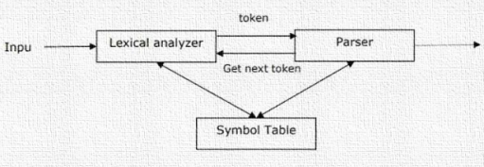

The main goals of Syntax Analysis are:
- Check grammatical correctness of program
- Build a Parse Tree or a Syntax Tree
- Detect syntax errors
- Prepare input for semantic analysis and code generation

Parse Tree (Syntax Tree) is a hierarchical representation of the program structure. It represents how the source code is derived from grammar rules
It shows relationships between statements, expressions, operators and operands.
It is built using input tokens, and grammar production rules.
Abstract Syntax Tree (AST) is a simplified form of the Parse Tree, which removes unnecessary grammar details while preserving the program structure.
It is used in semantic analysis, optimization, intermediate code generation, and machine code generation.

Working of Syntax Analysis:
- Receive Tokens
- The Syntax Analyzer receives tokens from the Lexical Analyzer.
- Example: for “int a = 10;”, the tokens would be ‘int’, ‘a’, ‘=’, ‘10’ and ‘;’
- Apply Grammar Rules
- The Parser checks whether the token sequence follows language grammar.
- Example: Declaration → datatype identifier ;
- Construct Parse Tree
- If grammar rules match correctly, a Parse Tree is generated
- Error Reporting
- If grammar rules are violated, syntax errors are generated
- Example: for “int = a 10;“ has incorrect syntax

Parsing is the process of analyzing tokens according to the grammar rules to determine syntactic correctness

Types of Parsing Algorithms:
- LL Parsing
- LL Parsing reads input from left to right, and produces the leftmost derivation.
- It is a type of Top-Down Parsing technique, which starts from the root of the parse tree and expands non-terminals step-by-step.
- It is simple, and easy to implement.
- LR Parsing
- LR Parsing reads input from left to right, and produces the rightmost derivation in reverse.
- It is a type of Bottom-Up Parsing technique that starts from leaves (tokens) and gradually reduces them into higher-level structures
- It is more powerful than LL Parsing and handles larger grammar classes
- LR(1) Parsing
- It is an advanced variant of LR Parsing that uses lookahead to remove ambiguity.
- It is more accurate in parsing decisions
- LALR Parsing
- This is a simplified version of LR Parsing that uses fewer parser states
- It reduces memory usage, and is efficient and practical

Top-Down vs Bottom-Up Parsing
Feature | Top-Down Parsing | Bottom-Up Parsing
Starts From | Root | Leaves
Builds Tree | Top to Bottom | Bottom to Top
Example | LL Parsing | LR Parsing
Complexity | Simpler | More Complex
Power | Less Powerful | More Powerful

Features of Syntax Analysis:
- Syntax Trees
- Syntax Analysis creates Syntax Trees which represent the hierarchical program structure.
- The tree shows relationship between various parts of code including statements, expressions and operators
- Context-Free Grammar (CFG)
- Syntax Analysis uses CFG to define programming language syntax.
- CFG is used to specify valid structures in a programming language
- Top-Down and Bottom-Up Parsing
- Syntax Analysis can be done using two main approaches: top-down parsing and bottom-up parsing
- Top-down parsing starts from the highest-level structure and expands downward
- Bottom-up parsing starts from the tokens and combines token upward
- Error Detection
- Detects syntax errors in programs and stops compilation when grammar rules are violated
- Intermediate Code Generation
- Syntax Analysis generates intermediate representation of code
- Easier for compiler phases to process
- Optimization
- Can simplify expressions and remove redundant structures

Production Rules makes up the grammar of a programming language. They define how symbols can be replaced.
Example of Production Rule:
Grammar:
- S → cAd
- A → bc | a
Input String: cad
- Step 1

- Step 2
Choose S → cAd
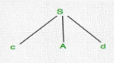 produces “cAd”
- Step 3
Choose A → bc
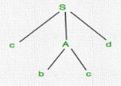 produces “cbcd”, which does not match the input string “cad”. Therefore, backtrack is needed
- Step 4
Parser backtracks and chooses A → a
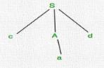 produces “cad”

Steps in Syntax Analysis
- Tokenization
- Source program is converted into tokens such as keywords, operators, separators/punctuation, identifiers etc.
- Parsing
- Tokens are checked using grammar rules of the programming language, and a Parse Tree or AST is generated
- Error Handling
- Syntax errors are detected and reported, along with parser identifying error location
- Symbol Table Creation
- Syntax Analyzer creates a Symbol Table, which is a data structure to store information about identifiers used in programs like their type, scope, location etc.,
- Prerequisite for Subsequent Phases
- If Syntax Analysis is performed incorrectly, the compiler may generate incorrect code or fail to compile program altogether

Advantages of Syntax Analysis:
- Structural Validation
- Ensures source code follows grammar rules
- Detects syntax errors early
- Improved Code Generation
- Parse Trees help generate optimized machine code
- Easier Semantic Analysis
- Structural information simplifies semantic checking

Disadvantages of Syntax Analysis:
- Complexity
- Parsing complex grammars is difficult
- Ambiguous grammars make implementation harder
- Reduced Performance
- Adds extra overhead for compilation
- Limited Error Recovery
- Some parsers cannot recover properly after syntax errors
- Can produce incomplete parse trees

Week 13 – Reverse Engineering Techniques: Control Flow Analysis
Control Flow Analysis studies how execution moves through a program.
It comes after Lexical Analysis and Syntactical Analysis.
It determines order of statement execution, branching paths, function calling relationships, and possible execution flows.

Types of Control Flow Analysis:
- Intra-Procedural Analysis – is used to determine the sequence of statements that are executed inside one subprogram, procedure or function. It focuses on internal logic of procedure including conditions, loops, branches, and sequential execution
- Inter-Procedural Analysis – studies the relationship between multiple procedures/functions and shows which functions call another function. It is performed by constructing a call graph, which is a directed graph where each function/procedure is represented by a node and the edge from node f to g represents that function f calls function g

Example of Call Graph:
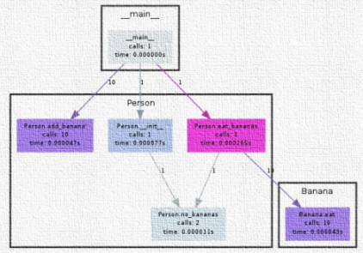
Control Flow Graph (CFG) is a graphical representation of the flow of control in a program during execution. It visually represents all possible execution paths.
CFG is mainly used for static analysis, compiler design, program optimization, reverse engineering, software testing, and detecting unreachable code

Characteristics of Control Flow Graph (CFG):
- CFG is process-oriented, and focuses on execution process & flow
- CFG represents every possible execution path
- CFG is a directed graph.
- Each node represents one basic block
- Each edge indicates flow of execution between blocks

Basic Block is a sequence of statements with one entry point and exit point.
Example:
a = 5;
b = 10;
c = a + b;
- This entire sequence forms one basic block.

There are two designated blocks in CFG:
- Entry Block – starting point of CFG from where execution enters the graph
- Exit Block – final point of CFG from where execution leaves the graph

A CFG generally contains:
- Start node
- End node
- Basic blocks
- Directed control flow edges

General Control Flow Graphs:
- If-Else
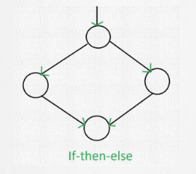
Example:
if (a > b)
max = a;
else
max = b;
- Case (Switch)
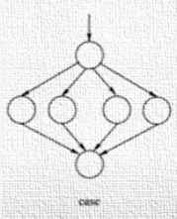
Example:
switch(x)
{
case 1:
break;
case 2:
break;
case 3:
break;
case 4:
break;
}
- While Loop
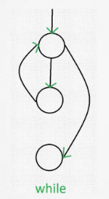
Example:
while(i < 10)
{
i++;
}

- Do-While Loop
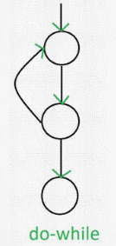
Example:
do
{
i++;
}
while(i < 10);
- For Loop
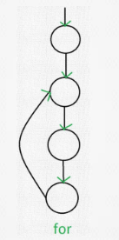
Example:
for(i=0; i<5; i++)
{
sum += i;
}

Examples of Control Flow Analysis:
Example 1:
if A = 10 then
if B > C
A = B
else A = C
endif
Endif
print A, B, C

Flow Chart:  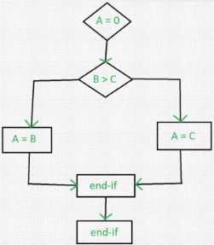 | Control Flow Graph:  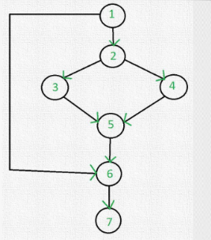

Example 2:
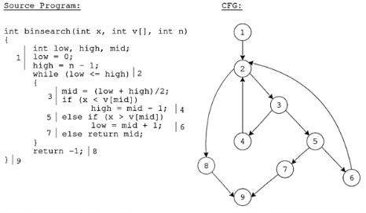

Week 14 – Reverse Engineering Techniques: Data Flow Analysis
Data Flow Analysis (DFA) studies how data values move through a program.
It determines where the variables are defined, where they are used, and how their values propagate throughout the program

The main purpose of DFA is:
- To analyze the definition and use of variables in a program
- To identify optimization opportunities
- To detect possible programming errors

Data Flow Property is the information computed by Data Flow Analysis about variables and expressions at different points in a program.

Goals of Data Flow Analysis:
- Optimization – improve execution efficiency
- Error Detection – detect improper variable usage
- Program Understanding – understand how data moves through software

DFA can be used to detect Data Flow Anomalies, which are suspicious or incorrect patterns in variable usage
Examples of Data Flow Anomalies:
- Referencing an undefined variable
Example:
int a;
b = a + 1; // variable b is undefined before use
- Variable being defined more than once, without being referenced in between
Example:
x = 5;
x = 10; // first assignment becomes useless if x is not used before redefinition
DFA can detect uninitialized variables, unreachable code, unused assignments and variables not defined before use.

DFA models the program as a graph, where:
- Node represent program statements
- Edges represent data flow dependencies between statements

Data flow information is then propagated through the graph via a set of rules and equations to compute the value of each variable and expression at each point.

Basic Terminologies:
- Definition Point – where a variable gets a value
- Reference Point – where a variable is used/read
- Evaluation Point – where an expression is evaluated
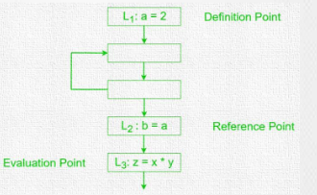

Data Flow Properties:
- Available Expressions (Forward Analysis)
An expression (a+b) at program point ‘x’ is said to be available, if none of its operands get modified before their use.
Example of Available Expression:
B1:
y = c - d
B2:
if (z > 0)
a = 10
else
y = 20
B3: w = a + b
At the end of B1, the expressions { a+b, c-d } are available.
In B2, if the if branch is taken, a is modified. This “kills” the expression a+b.
Result: At the start of B3, a+b is not available because there is at least one
path (the if branch) where its value was changed. The compiler must recompute
a+b.

It is used for common subexpression elimination
Before Elimination:  a = 10;  b = a + 1 * 2;  c = a + 1 * 2;  // ‘c’ has a common expression as ‘b’  d = c + a;  After Elimination:  a = 10;  b = a + 1 * 2;  d = b + a; | 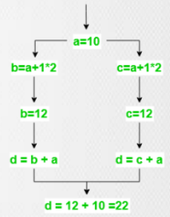
This avoids repetitive computation.
- Reaching Definition (Forward Analysis)
A definition D reaches to a point X if D is not killed or redefined before that point
It is used in constant & variable propagation (meaning if reaching definition of all variables have same assignment, then variable has a constant value and can be substituted with the constant)
Example of Reaching Definition:
D1: x = 4;
D2: x = x + 2;
D3: y = x + 2;
D1 reaches D2, but it does not reach D3 as D2 redefines x
- Live Variable (Backward Analysis)
A variable is live at point P if it will be used later before redefinition, else it becomes dead/killed.
It is used for dead code elimination
Example:
- [B1]
a = 1
b = 2
e=20
- [B2]
c = a + 5
a = 10 ← ‘a’ is redefined here
- [B3]
d = b + a
return d
Analysis (Working Backward):
- In B3: b and a are used. So, at the start of B3, {a, b} are Live.
- In B2: a = 10 kills the previous value of a. However, c = a + 5 uses the old value of a.
- Result: At the end of B1, the live variables are {a, b}. If the code had an assignment e = 20 in B1 that was never used in B2 or B3, e would be “Dead” and the compiler would delete it.
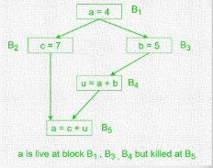
- Busy Expression
An expression is busy if it will definitely be evaluated later and its operands are not modified before evaluation.

Features of Data Flow Analysis
- Identifying Dependencies – detects relationships between statements & variables, such as determining which statement modify or read variables
- Detecting dead code – detects code that is unexecuted or produces unused values. Example: x=5; x is dead if never used
- Optimizing code – supports constant folding, common subexpression elimination, dead code removal etc.,
- Detecting Errors – detects uninitialized variables and incorrect variable usage

Advantages of Data Flow Analysis
- Improved Code Quality – optimizes code making it faster, smaller, and efficient
- Better Error Detection – finds hidden bugs and anomalies
- Better Program Understanding – helps programmers understand program behavior

Week 15 – Reverse Engineering Techniques: Program Slicing
Program Slicing is a technique to extract relevant subset of a program from a potentially large program
Given a potentially large program, slicing tries to extract an executable subset of this program that (potentially) affects the values that exist at a particular program location.

Slicing Criterion consists of Program Location and Variable i.e.,
Slicing Criterion = Program Location + Variable

The goal is to determine which statements affect the value of a variable at a particular location in the program

Example:
Consider the following as the full program:
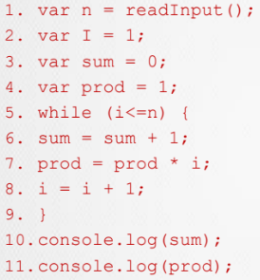

- Slice for the value of “sum” at statement 10? (statement 10, variable sum)
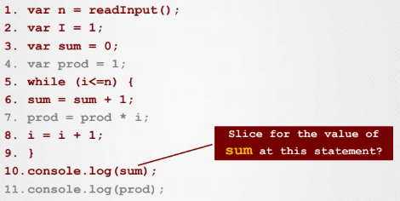
- Slice for the value of “prod” at statement 11? (statement 11, variable prod)
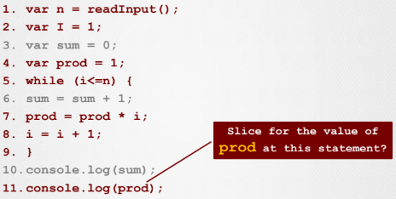
- Slice for the value of “n” at this statement 5? (statement 5, variable n)
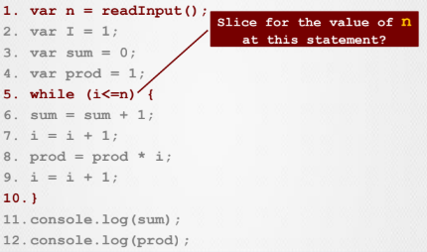

Types of Program Slicing:
- Backward vs Forward Slicing
  - Backward Slicing – finds statements that influence the slicing criterion. The main idea is to start from variable and program point, and move backward to find dependencies.
It is used to determine why a variable has a particular value at a particular point.
It is mainly used for debugging.
Example:
L1: x = 5;
L2: y = x + 2;
L3: z = y * 3;
Backward slice for z includes L1, L2, L3
  - Forward Slicing – finds statements influenced by the slicing criterion. The main idea is to start from a statement and determine which future statements are affected.
It is mainly used for impact analysis
Example:
L1: x = 5;
L2: y = x + 2;
L3: z = y * 3;
Forward slice from x = 5 includes L2, L3
- Static vs Dynamic Slicing
  - Static Slicing – analyzes source code to extract program slices without executing programs. It considers all possible paths and usually produces larger slices.
  - Dynamic Slicing – analyzes the program to extract fragments of a larger program during execution. It considers only executed paths and produces more precise slices

Applications of Program Slicing:
- Debugging – helps identifying statements responsible for bugs. Example: if a variable has incorrect value, slice identifies influencing statements.
- Program Understanding – helps developers understand dependencies.
- Change Impact Analysis – determines which parts of the program are affected after modification. Helps in deciding what to retest and which modules are impacted.
- Parallelization – determines independent program parts that can be executed simultaneously

Week 16 – Restructuring & Refactoring
Software systems continuously evolve over time.
Developers regularly modify software, enhance features, and adapt software to new environments & requirements.
During evolution, software gradually moves away from its original design and architecture.

Problems caused by Software Evolution:
- Decreased Understandability – software becomes harder to understand, and complex & poorly organized code reduces maintainability
- Decreased Reliability – reliability decreases as deviation from original design occurs, documentation becomes outdated & code structure deteriorates, bugs are unintentionally introduced during maintenance.
- Increased Maintenance Cost – poorly structured software requires more time, effort and resources for maintenance and updates.

The difficulty in understanding software is due to:
- Increased code complexity
- Outdated documentation
- Code not conforming to standards

Therefore, it is necessary to restructure the software:
- To reduce software complexity
- To improve internal software quality
- To make software easier to maintain and evolve

If restructuring is performed on an object-oriented software, then it is called refactoring.

Restructuring – reorganization of software to improve its structure and appearance. The main goal is to improve non-functional qualities without changing functionality
Restructuring improves readability, maintainability, extensibility, and modularity.
It is necessary to increase software value.

Types of Software Value:
- External Software Value – value of software perceived by customers. Example: faulty software that fails to satisfy business needs may be seen to have lesser value
- Internal Software Value – cost savings achieved internally through better software structure.
It includes maintenance cost saved due to good software structure, cost saved via component reuse, and cost saved by making software maintainable and extending its lifetime.

Some simple restructuring activities include:
- Pretty Printing – formatting code and ensuring proper alignment so that code is easier to understand
- Meaningful Variable Names – using variable names that indicates its purpose
- One Statement Per Line – writing one code statement in one line

Reasons for Software Restructuring:
- Better Understanding – well-organized structures are easier to understand
- Keep Pace with New Structures – old software may require restructuring to match modern practices as developers learn new programming styles & structures
- Better Reliability – bugs are easier to identify and fix in structured systems
- Longer Software Lifetime – maintainable systems survive longer
- Automated Analysis – structured software is easier for automated tools to analyze

Characteristics of Restructuring and Refactoring:
- Improve Internal and External Value
- Preserve External Behavior
- No New Functional Requirements
- Preserve Level of Abstraction

Refactoring – process of improving internal structure of object-oriented software without changing external behavior. It means improving code quality while preserving functionality.

Steps to restructure/refactor software:
- Identify What To Refactor – determine which software artifacts (such as source code, design documents, requirement documents, test suites etc.,) require refactoring
- Determine Suitable Refactorings – decide which refactoring techniques to apply and avoid conflicts & inconsistencies
- Preserve Software Behavior – ensure functionality remains unchanged. Other than ensuring the preservation of input-output behavior, the preservation of temporal constraints & non-functional requirements may be key.
- Apply Refactorings – execute selected refactoring operations on identified software components
- Evaluate Impacts on Quality – evaluate both internal and external quality of the system after refactorings.
Internal qualities include size, complexity, coupling, cohesion, testability etc.,
External qualities include performance, reusability, maintainability, extensibility, robustness, scalability etc.,
- Maintain Consistency – ensure all related software artifacts remain synchronized after refactoring

Week 17 – Decompilation Versus Reverse Engineering
Decompilation is a form of static analysis that investigates a program without executing it.
A decompiler takes an executable binary file and attempts to reconstruct readable high-level source code.

But the output generally may not be the same as original source code as it may lose formatting, lose comments, use different variable names or may not be in the same programming language.

Decompilation may be done unethically as well to reproduce source code for reuse without permission of the copyright holder.
To prevent unauthorized decompilation, programs may use protection techniques such as obfuscation, encryption, or code protection mechanisms

Examples of Decompilers: dotpeek for .Net, Hex Rays for C/C++
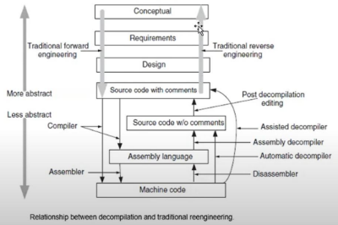
Data Reverse Engineering focuses on recovering and understanding database structures and data models from existing systems.
It helps organizations understand legacy databases when documentation is missing or outdated.
Main Areas of Data Reverse Engineering:
- Data Structure Extraction
- Data Structure Conceptualization

Database Reverse Engineering is the process through which logical & conceptual schemas of a legacy database, or of a set of files are reconstructed using various information sources like DDL code, data dictionary contents, database contents or the source code of application programs.
It is also defined as the use of structured techniques to reconstitute the data assets of an existing system.
Main Objectives of DRE:
- Recover Data Assets – extract available data structure & schemas
- Reconstitute Data Assets – improve & reorganize data to make it more useful
Purpose of DRE:
- Knowledge Acquisition – is a learning process involving elicitation, collection, analysis, modeling, and validation of information.
It helps developers understand old or undocumented systems, especially data-oriented applications and legacy databases.
- Tentative Requirements – identifies tentative requirements for system replacement so that original functionality is not forgotten during redevelopment.
- Documentation – helps create or recover documentation for old systems, which is very useful when original developers are unavailable.
- Integration – assists in integrating applications & databases, and as a logical model is a prerequisite for integration, it also helps in determining how a program will function in certain environmental conditions.
- Data Administration – aids in organizing databases, controlling data resources and managing information systems effectively.
- Data Conversion – helps in understanding the connection between old and new databases so that migration of data becomes easier.
- Software Assessment – helps in evaluating quality of database management systems as poor database structures may introduce faults and DRE helps identify weaknesses
- Quality Assessment – helps in assessing software quality as better database structure improves reliability, maintainability, and performance.
- Component Reuse – identifies reusable components which reduces development costs and efforts.

Phases of Forward Design Process of a database:
- Conceptual Phase – involves gathering user requirements, studying them and formalizing them into a conceptual schema.
- Logical Phase – involves converting conceptual schema into a logical data model. The data model is optimized according to the target model and its tables & relationships are defined.
- Physical Phase – involves implementation of the schema via DDL and programming language. It also includes defining physical storage structures, indexing and storage optimization.

Processes in Data Reverse Engineering:
- Data Structure Extraction – recovering database structures from existing systems.
The main processes in this phase includes:
  - DMS-DDL Text Analysis – analyzes DDL statements & application programs to recover approximate logical schema
  - Program Analysis – analyzes source code to detect integrity constraints, hidden data structures, and relationships
  - Data Analysis – analyzes files & databases to identify data properties, unique fields and functional dependencies.
  - Schema Integration – combines multiple partial schemas to produce a final integrated logical schema.
- Data Structure Conceptualization – involves deriving a conceptual schema from a logical schema of the database, where redundancies, DMS-dependent constructs, technical optimizations etc., are detected and removed.
This phases comprises of two sub-phases:
  - Basic Conceptualization – relevant semantic concepts are extracted from logical schema
  - Conceptual Normalization – basic conceptual schema is restructured for it to have desired qualities like readability, minimality, extensibility etc.,

Week 18 – Design Patterns
Design Patterns – is a reusable solution used by object oriented software developers

Types of Design Patterns:
- Singleton Pattern – is one of the simplest design patterns in Java that involves a single class which is responsible for creating an object while ensuring that a single object is created.
This class provides a way to access its only object, that can be accessed directly without the need to instantiate object
Example:
public class SingletonObject {
private static SingletonObject instance = new SingletonObject();
private SingletonObject() { }
public static Singleton getInstance() {
return instance;
}
public void showMessage() {
System.out. println(“Hello World”);
}
}
public class SingletonPatternDemo {
public static void main(String[] args) {
SingletonObject obj = SingletonObject.getInstance();
obj.showMessage();
}
}

- Factory Design Pattern – an object is created without exposing its creation logic to the client. Object creation is handled by a separate factory class.
Example:
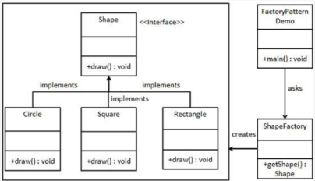
public interface Shape {
void draw();
}
public class Rectangle implements Shape {
public void draw() {
System.out.println (“Inside Rectangle::draw() method”);
}
}
public class Square implements Shape {
public void draw() {
System.out.println (“Inside Square::draw() method”);
}
}
public class Circle implements Shape {
public void draw() {
System.out.println (“Inside Circle::draw() method”);
}
}
public class ShapeFactory {
public Shape getShape(String shapeType) {
if (shapeType == null) {
return null;
}
if (shapeType.equalsIgnoreCase(“CIRCLE”))
return new Circle();
else if (shapeType.equalsIgnoreCase(“RECTANGLE”))
return new Rectangle();
else if (shapeType.equalsIgnoreCase(“SQUARE”))
return new Square();
return null;
}
}
public class SingletonPatternDemo {
public static void main(String[] args) {
ShapeFactory obj = new ShapeFactory();

Shape shape1 = obj.getShape(“CIRCLE”);
shape1.draw();

Shape shape2 = obj.getShape(“RECTANGLE”);
shape2.draw();

Shape shape3 = obj.getShape(“SQUARE”);
shape3.draw();
}
}

- Facade Design Pattern – hides complexities of system and provides a simple interface to a complex system. It hides logic of instantiation, and duplicity of code
Example:
class DVDPlayer {
public void on() {
System.out.println("DVD Player ON");
}
}
class Projector {
public void on() {
System.out.println("Projector ON");
}
}
class SoundSystem {
public void on() {
System.out.println("Sound System ON");
}
}
class HomeTheaterFacade {
private DVDPlayer dvd = new DVDPlayer();
private Projector projector = new Projector();
private SoundSystem sound = new SoundSystem();

public void watchMovie() {
dvd.on();
projector.on();
sound.on();
System.out.println("Movie Started");
}
}

public class Main {
public static void main(String[] args) {
HomeTheaterFacade theater = new HomeTheaterFacade();
theater.watchMovie();
}
}

- Adapter Design Pattern – works as a bridge between two incompatible interfaces. It involves a single class that is responsible for joining functionalities of independent or incompatible interfaces.

Examples:
class OldPrinter {
public void oldPrint() {
System.out.println("Printing using Old Printer");
}
}
interface ModernPrinter {
void print();
}
class PrinterAdapter implements ModernPrinter {
private OldPrinter oldPrinter;
public PrinterAdapter(OldPrinter oldPrinter) {
this.oldPrinter = oldPrinter;
}
public void print() {
oldPrinter.oldPrint();
}
}
public class Main {
public static void main(String[] args) {
OldPrinter oldPrinter = new OldPrinter();
ModernPrinter adapter = new PrinterAdapter(oldPrinter);
adapter.print();
}
}

